谭树杰 11849060

Lab4 Report

**The main() function of this project is shown below**





1. Implement 2D DFT for all provided images and analyze their transformed images in frequency domain :

My implementation code is shown below:



But there’s a bug in it, so the result correct enough. Therefor I use the code in 《OpenCV图像处理编程实例》 to analysis DFT.

bridge.jpg,circles.jpg,crosses.jpg,goldhill.jpg,horiz.jpg, lena.jpg, montage.jpg and their magnitude images after dft transformation are shown below, respectively

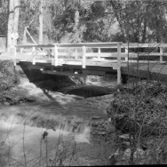 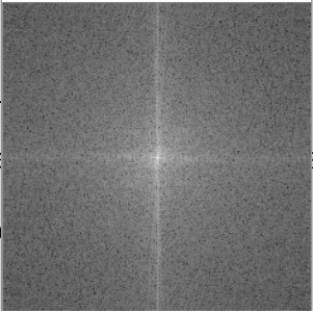  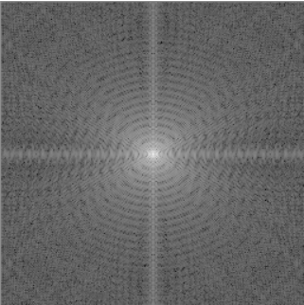

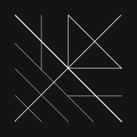 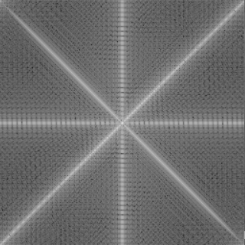 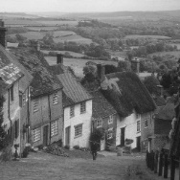 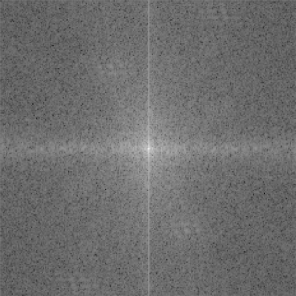

 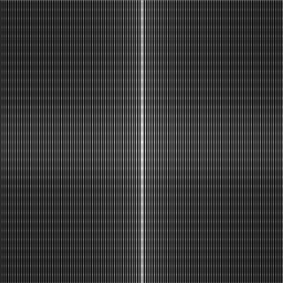 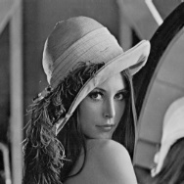 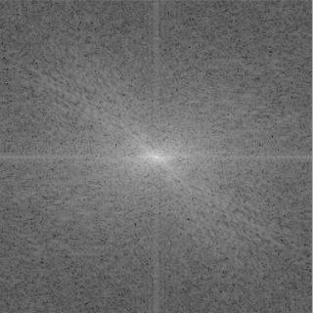

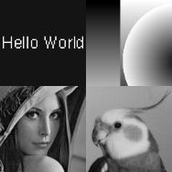 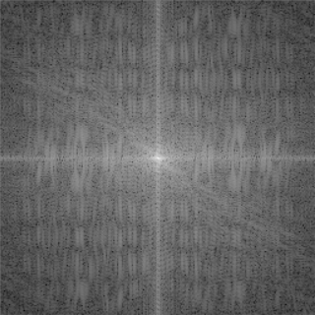

Analysis: We could only see bright lines in crosses.jpg and horiz.jpg, because these two images have a black background and several bright lines in it. The intensity changes dramatically in the areas of lines. In contrast, other magnitude images just have a bright dot in the center and with gray background. Because these images have a slower intensity transition.­

1. Obtain the magnitude image and phase images of the Lena.pgm and analyze the resulted images.

The implementation code is just as above.

The lena.jpg and its magnitude and phase image are shown below

Analysis: The lena.jpg’s intensity only changes dramatically in her hat’s edge and her arm. So the magnitude image only has several bright line across the image. And it’s hard to get some intuitive information from the phase image.

  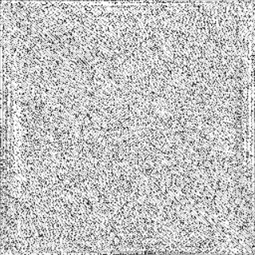

1. Reconstruct lena.pgm using the magnitude and phase images in frequency domain respectively and analyze the results.

The implementation code is shown below. But it does not work well enough too.



Analysis: The image doesn’t as well as original image. Maybe due to the DFT transformation lost some information of the image.